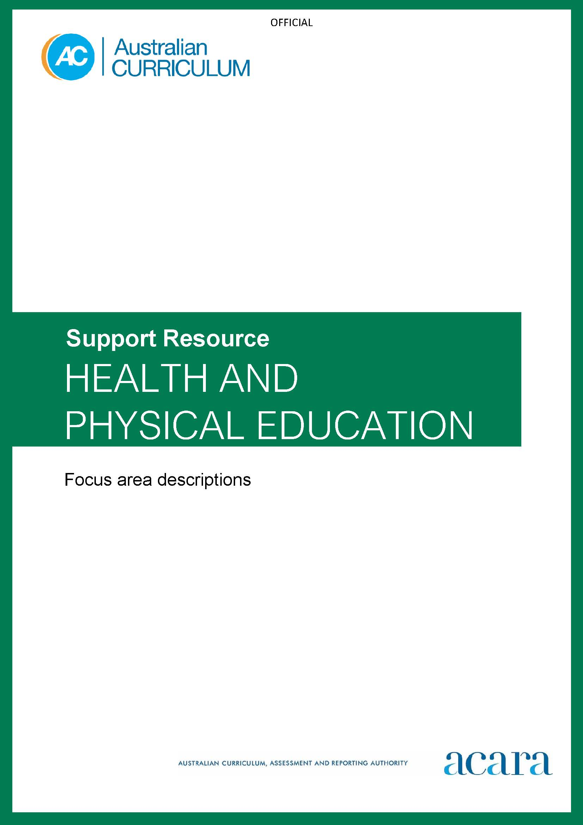

Copyright and Terms of Use Statement
© Australian Curriculum, Assessment and Reporting Authority 2022
The material published in this work is subject to copyright pursuant to the Copyright Act 1968 (Cth) and is owned by the Australian Curriculum, Assessment and Reporting Authority (ACARA) (except to the extent that copyright is held by another party, as indicated).
The viewing, downloading, displaying, printing, reproducing (such as by making photocopies) and distributing of these materials is permitted only to the extent permitted by, and is subject to the conditions imposed by, the terms and conditions of using the ACARA website (see, especially, clauses 2, 3 and 4 of those terms and conditions). The terms and conditions can be viewed at https://www.acara.edu.au/contact-us/copyright
TABLE OF CONTENTS
F–10 AUSTRALIAN CURRICULUM: Health and physical education focus areas 4
Introduction 4
Health and Physical Education – Focus Areas 5
Alcohol and other drugs 5
Food and nutrition 5
Health benefits of physical activity 6
Mental health and wellbeing 6
Relationships and sexuality 7
Safety 7
Active play and minor games 8
Challenge and adventure activities 8
Fundamental movement skills 9
Games and sports 9
Lifelong physical activities 10
Rhythmic and expressive activities 10

F–10 AUSTRALIAN CURRICULUM: Health and physical education focus areas

Introduction
The content descriptions in the Australian Curriculum: Health and Physical Education must be taught through 12 focus areas.
The focus areas provide the breadth of learning across Foundation to Year 10 that students require to demonstrate the knowledge, understanding and skills described in the achievement standard for each band of learning.
The band level descriptions provide guidance about how each focus area can be addressed in the band.
Content elaborations provide further detail about how and when elements of the focus areas can be addressed in bands of learning.
Decisions about the specific timing of individual aspects of each focus area being taught are the responsibility of schools and teachers. Planning decisions should consider local needs, available resources, students’ readiness and community priorities.

Health and Physical Education – Focus Areas

Alcohol and other drugs
This focus area addresses learning about safe practices in relation to a range of drugs. In the early years, safe practices related to medication, prescription drugs and household poisons are introduced. Students progress to learning about safe practices in relation to natural and alternative medicines, energy drinks and caffeine. When appropriate, students progress to learning about tobacco, alcohol, e-cigarettes and other synthetic drugs, cocaine, ecstasy and methamphetamines. When teaching about alcohol and other drugs, it is important to challenge students’ perceptions that substance use is the norm among other young people. The prevalence of substance use in students’ age group can be examined using large, high-quality national surveys.
It is expected that all students at appropriate times across the continuum of learning from Foundation to Year 10 will learn about:
- safe use of medicines
- alternatives to taking medicines
- the effects of drugs on the body (including energy drinks and caffeine)
- factors that influence the use of different types of drugs
- the impacts of drug use on individuals and communities
- making informed decisions about drugs (assertive behaviour, peer influence, harm minimisation, awareness of blood-borne viruses).

Food and nutrition
This focus area addresses the role of food and nutrition in enhancing health and wellbeing. The content supports students to make healthy, informed food choices. They explore the contextual factors that influence eating habits and food choices.
It is expected that all students at appropriate times across the continuum of learning from Foundation to Year 10 will learn about:
- personal, social, economic and cultural influences on food choices and eating habits
- strategies for planning and maintaining healthy, balanced nutrition (including serving sizes and recommendations for daily intakes)
- healthy and sustainable options for snacks, meals and drinks
- quality of food and diet (food groups and variety, processed versus real foods, sustainable production practices, food miles).
- food groups and recommendations for healthy eating (including The Australian Guide to Healthy Eating and Aboriginal and Torres Strait Islander Guide to Healthy Eating)
- nutritional requirements and dietary needs (including The Australian Dietary Guidelines)
- food labelling and packaging (including reading and interpreting nutritional panels)
- food advertising and messaging (including health and nutrition messages distributed through social media networks)

Health benefits of physical activity
This focus area addresses the impact regular physical activity participation has on individual and community health and wellbeing. The content supports students to develop knowledge, understanding and skills to make active choices. Students explore influences on physical activity participation and choices.
It is expected that all students at appropriate times across the continuum of learning from Foundation to Year 10 will learn about:
- physical benefits of participating in physical activities (including health-related and skill-related components of fitness)
- benefits of physical activities based on intensity, nature, duration and frequency
- social, emotional and cognitive benefits of regular physical activity
- social, cultural and environmental influences on physical activity participation
- sedentary behaviours and their impact on health and wellbeing
- strategies for minimising sedentary behaviour and including moderate physical activity in daily routines.

Mental health and wellbeing
This focus area addresses how mental health and wellbeing can be enhanced and strengthened at an individual and community level. The content teaches students to maintain and enhance their own mental health and wellbeing, and to support that of others.
It is expected that all students at appropriate times across the continuum of learning from Foundation to Year 10 will learn about:
- identity and belonging
- emotional awareness
- emotional regulation
- mental health promotion
- strategies for enhancing mental health and wellbeing, including perseverance, adaptability, positive self-talk, mindfulness, meditation, connecting with others
- destigmatising mental illness in the community
- the impact of physical, social, spiritual and emotional health on wellbeing
- body image and self-worth, and their impact on mental health and wellbeing
- resilience and skills that support resilient behaviour
- coping skills, help-seeking strategies and community support resources
- networks of support for promoting mental health and wellbeing and critiquing health information

Relationships and sexuality
This focus area addresses physical, social and emotional changes that occur over time and the significant role relationships and sexuality play in these changes. The content supports students to establish and manage respectful relationships. It also supports them to develop positive and respectful practices in relation to their reproductive and sexual health and their identities. In doing so, students gain understanding of the factors that influence gender and sexual identities.
It is expected that all students at appropriate times across the continuum of learning from Foundation to Year 10 will learn about:
- puberty and how the body changes over time
- practices that support reproductive and sexual health (contraception, negotiating consent, and prevention of sexually transmitted infections and blood-borne viruses)
- the nature of consent, seeking permission and setting boundaries, understanding the harm that can be caused when consent isn’t gained or is ignored
- the impact of power and coercion on boundary setting in relationships
- establishing and managing changing relationships (offline and online)
- strategies for dealing with relationships when there is an imbalance of power (including seeking help when wanting to end the relationship)
- bullying, harassment, discrimination and violence (including discrimination based on race, gender and sexuality)
- understanding the nature of gender-based violence and the beliefs and attitudes that drive this behaviour.

Safety
This focus area addresses safety issues that students may encounter in their daily lives. The content supports students to make safe decisions and behave in ways that protect their own safety and that of others.
It is expected that all students at appropriate times across the continuum of learning from Foundation to Year 10 will learn about:
- safe practices at school and home, in road or transport environments, in the outdoors, near water
- strategies for dealing with unsafe or uncomfortable situations
- protective behaviours and help-seeking strategies (saying no assertively, leaving situations that are unsafe or uncomfortable, telling a trusted adult, accessing credible information, seeking advice from a trusted friend, accessing services that support young people; for example, local youth services, kidshelpline, headspace)
- safe practices when using digital tools and online services, including dealing with cyberbullying
- managing personal safety
- first aid and emergency care, including safe blood practices
- safety when participating in physical activity, including sports safety, sun safety, use of protective equipment and modifying rules
- relationship and dating safety.

Active play and minor games
This area focuses on learning through play with people, objects and representations – indoors, outdoors, alone, with a partner or in a group. The content supports students to be physically active and develop creativity, persistence, negotiation, problem-solving, planning and cooperation.
It is expected that all students at appropriate times across the continuum of learning from Foundation to Year 10 will participate in:
- active play – can occur indoors or outdoors, alone or with others, and can be structured, unstructured or spontaneous
- imaginative play – developing creativity through activities involving movement
- role-play – activities where students act out or perform allocated roles to develop skills and understandings
- small group games – games played with 2–6 players that focus on developing skills such as problem-solving, planning, cooperation
- minor games – games with few rules, designed to allow students to practise skills, tactics and strategies in a challenging situation
- lead-up games – games that isolate one or more of the skills, rules and/or strategies used to play the actual sport it mimics.

Challenge and adventure activities
This area focuses on how individuals participate in a variety of physical activities that challenge them physiologically, behaviourally and socially in diverse environments. The content supports students to assess hazards and manage risks.
It is expected that all students at appropriate times across the continuum of learning from Foundation to Year 10 will participate in:
- initiative games
- movement challenges that focus on developing personal and social capabilities (as individuals and in teams or groups)
- recreational activities in natural and outdoor settings
- navigational challenges.

Fundamental movement skills
This area focuses on the development of fundamental movement skills that support competent and confident participation in a range of physical activities.
It is expected that all students at appropriate times across the continuum of learning Foundation to Year 10 will practise and refine fundamental movement skills.
Locomotor and non-locomotor skills:
- rolling
- balancing
- sliding
- jogging
- running
- leaping
- jumping
- hopping
- dodging
- galloping
- skipping
- floating and moving the body through water.
Object control skills:
- bouncing
- dribbling
- throwing
- catching
- kicking
- striking.

Games and sports
This area focuses on the development of movement skills, concepts and strategies through a variety of games and sports. This content builds on learning in active play, minor games and fundamental movement skills. It is expected that all students at appropriate times across the continuum of learning from Foundation to Year 10 will participate in:
- modified games
- traditional games or sports
- culturally significant games and sports (such as traditional games of First Nations Australians and games of significance from the Asia region)
- non-traditional games and sports (including student-designed games and player-officiated games such as Ultimate Frisbee).

Lifelong physical activities
This area focuses on how participation in physical activity can enhance health-related fitness and wellbeing across the lifespan.
It is expected that all students at appropriate times across the continuum of learning from Foundation to Year 10 will participate in:
- individual and group activities (such as movement circuits, activity stations, skipping activities, playground games)
- active recreation activities, which could include but are not limited to:
  - street walks
  - parkruns
  - orienteering
  - scootering or skateboarding
  - swimming for performance, fitness or recreation
  - tai chi, yoga, Pilates
  - bushwalking
  - recreational or competitive cycling, mountain biking, BMX
  - gym classes, strength and resistance training.

Rhythmic and expressive activities
This area focuses on how movement can be composed and performed in response to equipment, beats and sounds, images, words and themes.
It is expected that all students at appropriate times across the continuum of learning from Foundation to Year 10 will participate in learning experiences that address:
- creative movement
- movement exploration
- dance styles and dance elements.

Schools could also offer the following activities:
- circus skills
- rhythmic gymnastics
- educational gymnastics
- tai chi, yoga.

